21-4-2015

Mike Rooijackers, Noor van Oekel, Jordi Knol, Maaike Jansen, Tim Hermens

Group E

Global GUI designs module D

PTS6

Table of Contents

Introduction 2

The GUI model 3

Lay-out standard 4

Anonymous User 5

0.1a Start screen 5

0.1a Register confirm 6

0.2 Register 7

0.3 Log In 7

Identified User – My Account 8

1.1 My information 8

1.2 My team 9

User without a team 9

User with a team 9

1.3 Scores 10

1.3.1 Most recent 10

1.3.2 Previous 11

Identified User – Pre Game 12

2.1 Pre game global information 12

Identified User – During Game 12

3.0 Newsfeed 13

3.1 Assignment description 14

3.2 Code Files 15

3.3 Compiling 15

3.4 Testing 16

3.5 Javadoc 17

3.6 Hints 17

3.7 Turn in 17

Identified User – End Game 19

4.1 Turned in 19

Log out 19

# Introduction

This document contains the screen designs for module D. And to provide more structure a GUI model has also been made, which shows how all the pages are connected to each other.

These design mainly revolve around the functionality that has to reside within a page and which lay-out is most suitable for it. What isn’t a part of these designs are subjects like use of color and images when these are not essential to the functionality.

Each chapter revolves around a category of screen designs and is interlude by part of the GUI model. In doing this it becomes more clear which part of the model belongs to which screen designs.

# The GUI model

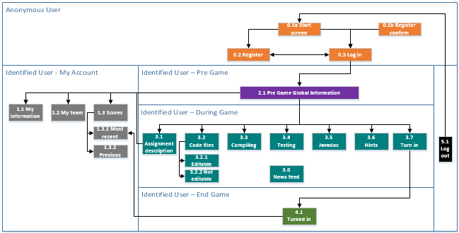

# Lay-out standard

In the following chapters each screen content is described. This lay-out standard describes what the entire page looks like.

By mistake the account / log in button is present in the content pages as well. Because this button is taken out of the content and placed in the bigger context please ignore its presence in the content pages.

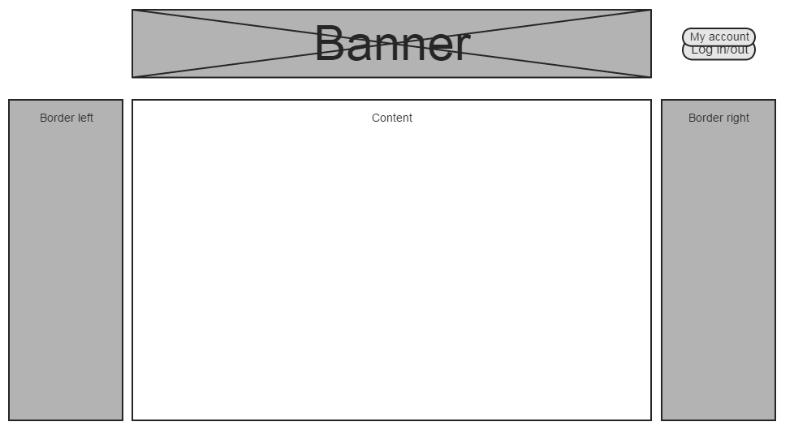

# Anonymous User

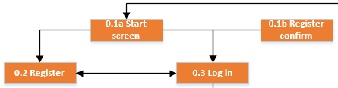

A user has to identify himself before he can participate in a competition. Before doing so he can only reach three screens. Because the functionality for these screens is pretty straight forward, the design itself has been kept simple.

## 0.1a Start screen

The welcome screen user see before identifying themselves.

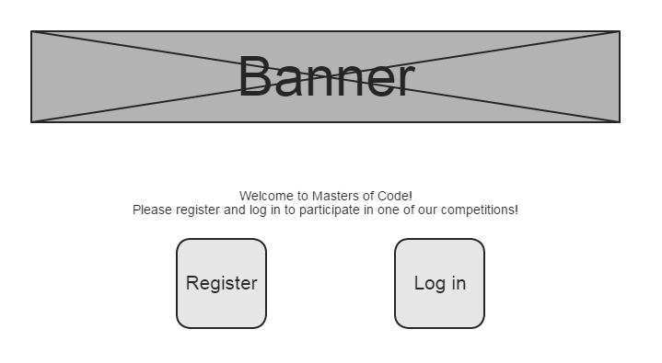

## 0.1a Register confirm

When the user registers himself he receives an e-mail with a link. By pressing the link he confirms that he wants to register and this screen is shown.

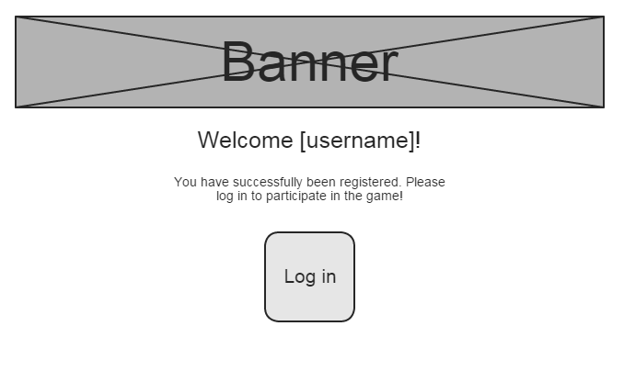

## 0.2 Register

Here users can register themselves so they can log in.

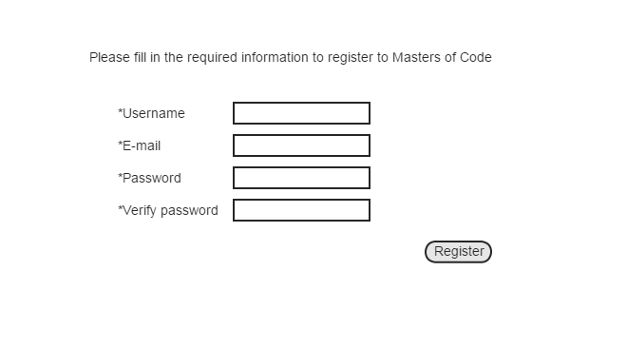

## 0.3 Log In

Here users can log in so they can participate in the game. They can reach the register screen via the “I don’t have an account yet” link.

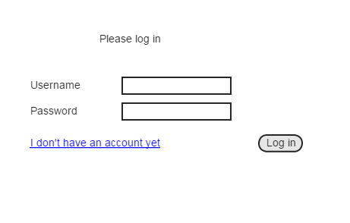

# Identified User – My Account

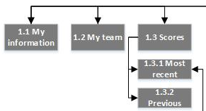

Once the user has identified himself he will be able to reach his own account from any of the other Identified User pages.

## My information

The user can view the information about his own account on this page. He is also able to change his password.

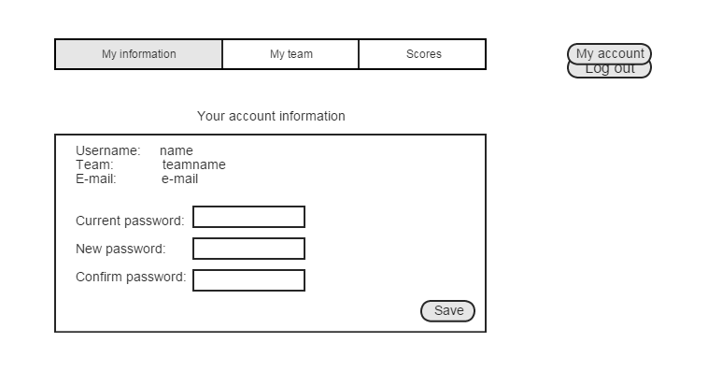

## My team

### User without a team

When a user doesn’t have a team yet this screen will allow him to send an invite to other people to join him. By clicking the “Add another member” link another E-mail slot appears. The invites will all be send out at once when the “Send team invites” button is clicked.

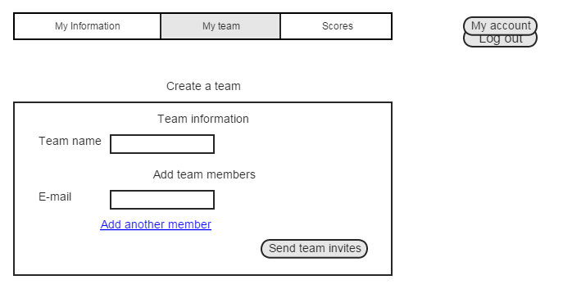

### User with a team

When a user already has a team the screen will show the team information. If the user was the team initiator he will also have the option to remove from or add members to the group. All users also have the option to leave the team they are currently part of.

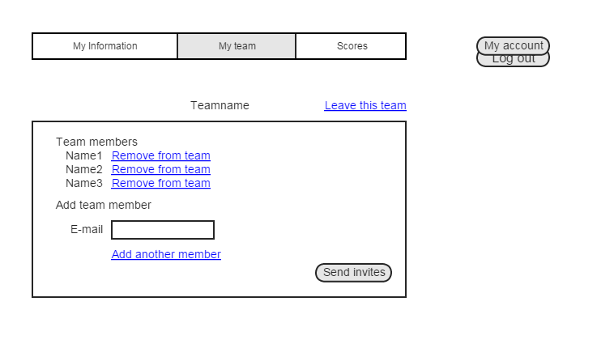

## Scores

The scores of previous games are shown on these pages.

### Most recent

In this screen the results of the most recent game will be displayed.

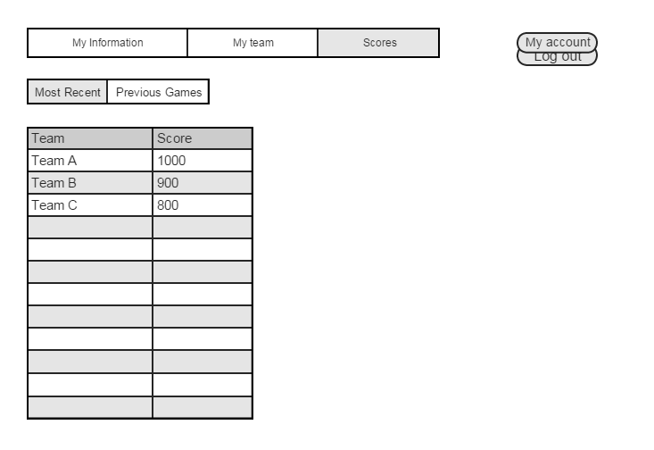

### Previous

In this screen the user can choose a game on the left and the results of that game will be shown on the right.

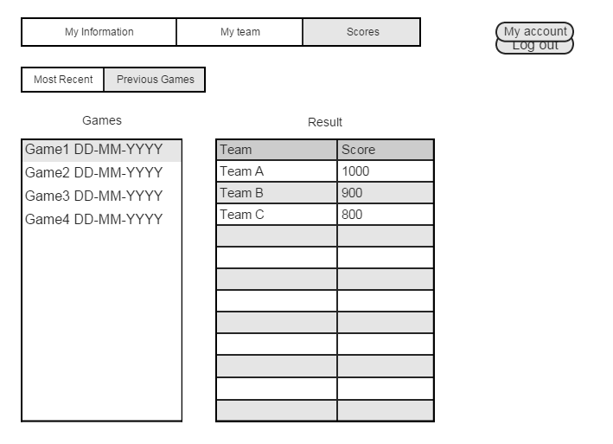

# Identified User – Pre Game

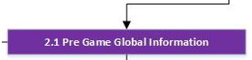

## 2.1 Pre game global information

Before a game is started the user will only be able to see the global information about that game.

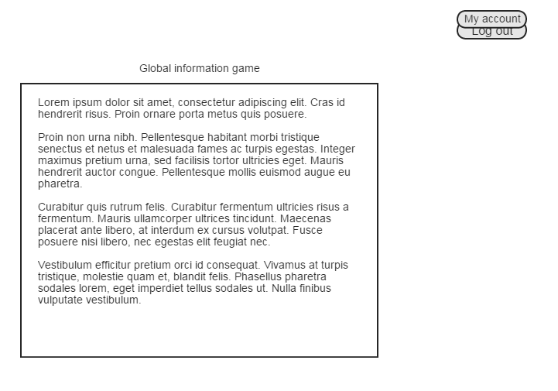

# Identified User – During Game

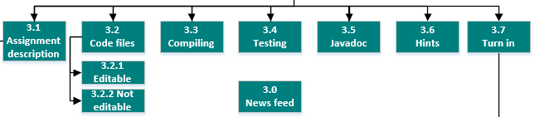

Once the game starts these screens will become available to the user, before and after the game they will not be reachable. All the screens in this category show a newsfeed, the remaining time, what the score of the user’s team would be if they turned in the assignment at that time and the scores of other teams.

## 3.0 Newsfeed

Each page has the newsfeed bar, in this bar information is being shown about the actions of all teams. When a new action is added to the newsfeed the text scrolls to the left. If a user wants to view all actions (also the ones that have been scrolled out of view) he can click on the newsfeed, this will send him to the newsfeed screen.

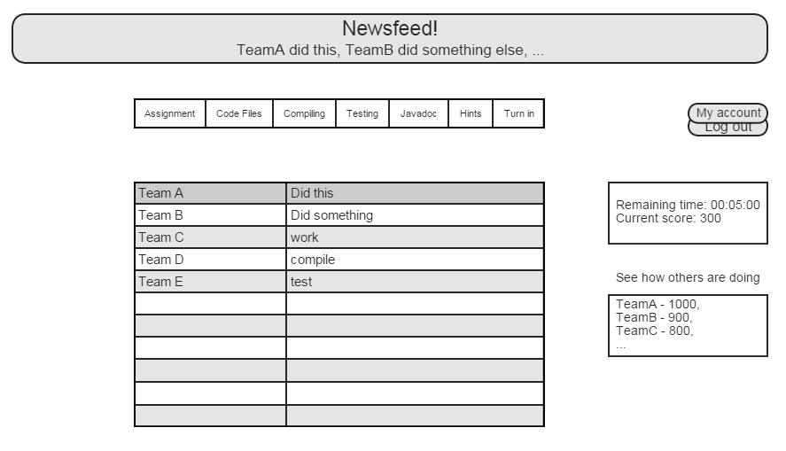

## 3.1 Assignment description

When the game starts the user gets redirected to this screen so he can read the assignment. During the game he can also navigate back to this screen via the menu buttons.

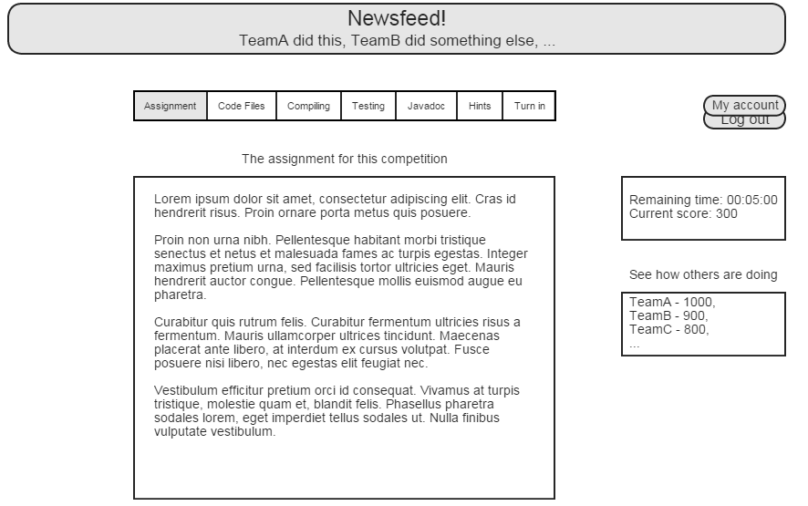

## 3.2 Code Files

The user is able to view the source code by choosing a file on the left. The code will be shown in the text box on the right. In case the user choose a editable source code file he can make changes in this text box by clicking on the “Edit/Save” button.

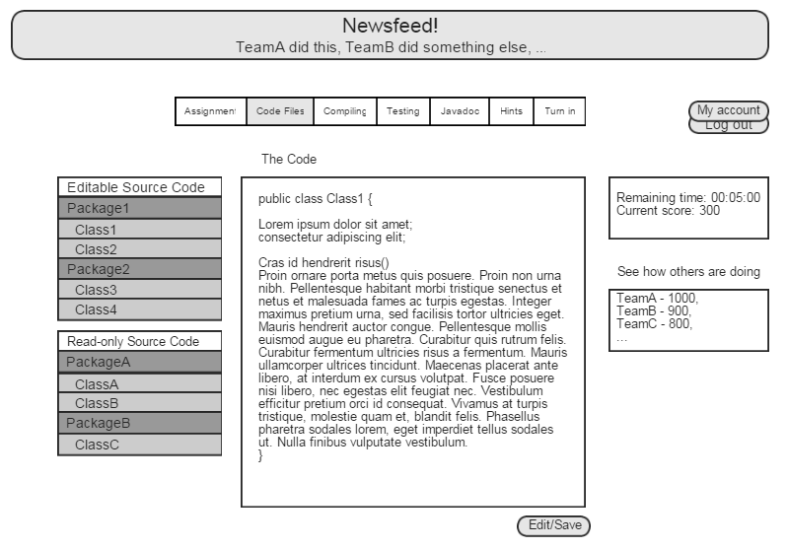

## 3.3 Compiling

The code will compile when the user clicks on the “Compile” button. Once it is done compiling the output will be shown in the textbox below.

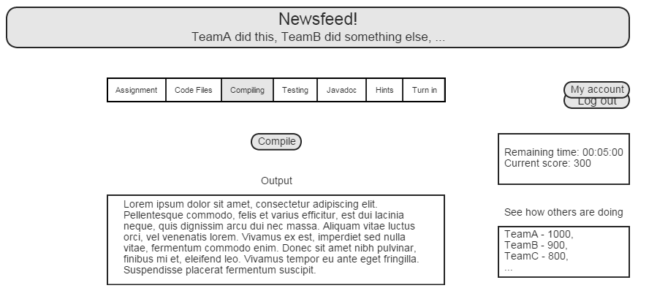

## 3.4 Testing

The available tests are shown on this screen. If they are orange they haven’t been run yet, red means they have been run and failed and green means the test has been run and passed. The user can choose via the checkboxes which tests he wants to run and he can confirm this with the “Test” button.

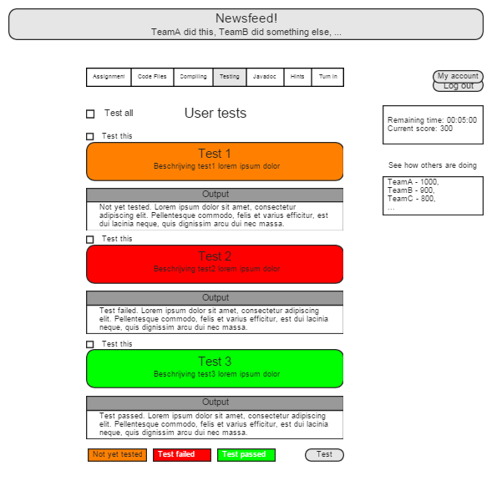

## 3.5 Javadoc

The user can choose an article on the left to be shown in the text box or he can use the search bar. Search results will be shown in the box on the left and will be removed if the search query is removed from the bar.

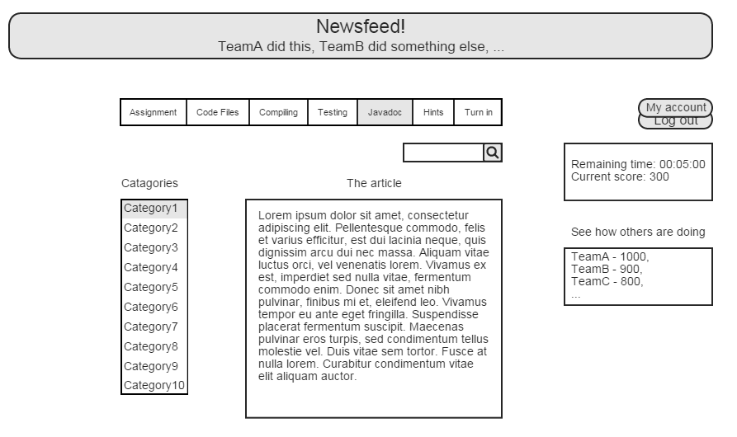

## 3.6 Hints

When a hint is given out it will appear on this screen.

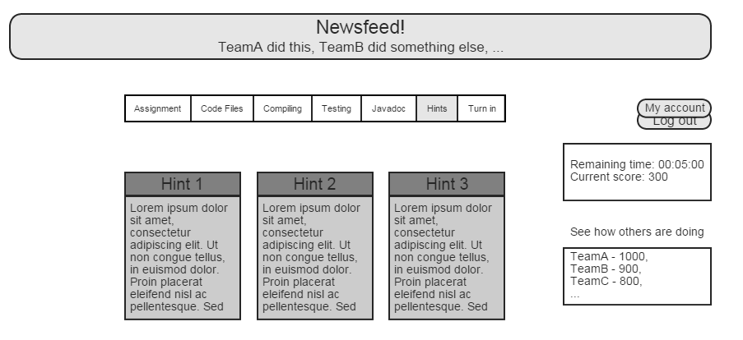

## 3.7 Turn in

By clicking the “Turn in” button the assignment as fulfilled by the team will be turned in, this will also end the game.

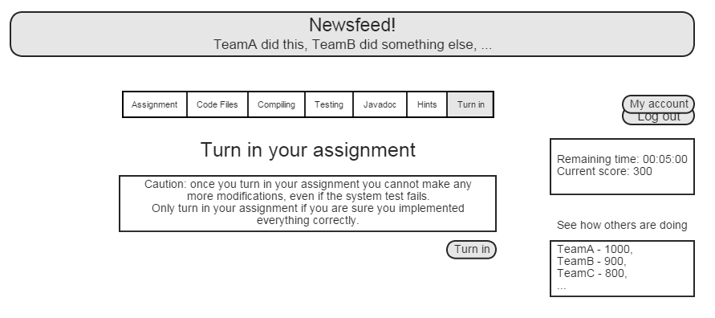

# Identified User – End Game

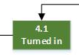

## 4.1 Turned in

Once the game has ended the user will get to see how much time he had remaining, what his acquired score is and what the output is for the system test. This screen is a pop up, once it’s closed the user will only be able to see screens that are not of the category “During Game” or “End Game”.

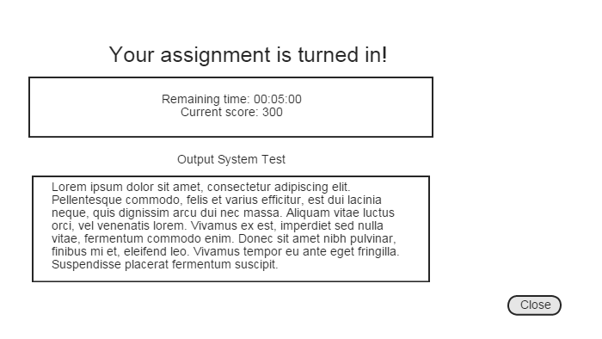

# Log out



Technically this is not a screen, but since it is a functionality that is present on all the screens of the identified user it has still be included in the GUI model. Each screen has a “Log out” button that appears when the user hovers over the “My account” button. By clicking on it the user is unidentified once again and is redirected to screen “0.1 Start screen”.